**Scenario:** I want to view the value of Bitcoin during the January 2018 price crash, and how this correlates with positive/negative social media news posts at the time.

**User story:**

As a user, I want to view the value of Bitcoin during the January 2018 price crash, as well as significant positive/negative reddit news posts regarding bitcoin at the time, so that I can determine the potential causes of the crash.

**Requirements:**

Database/table storage. Login/authentication system. Bitcoin price history page. Reddit bot to collect data. API.

**Use case diagram:**

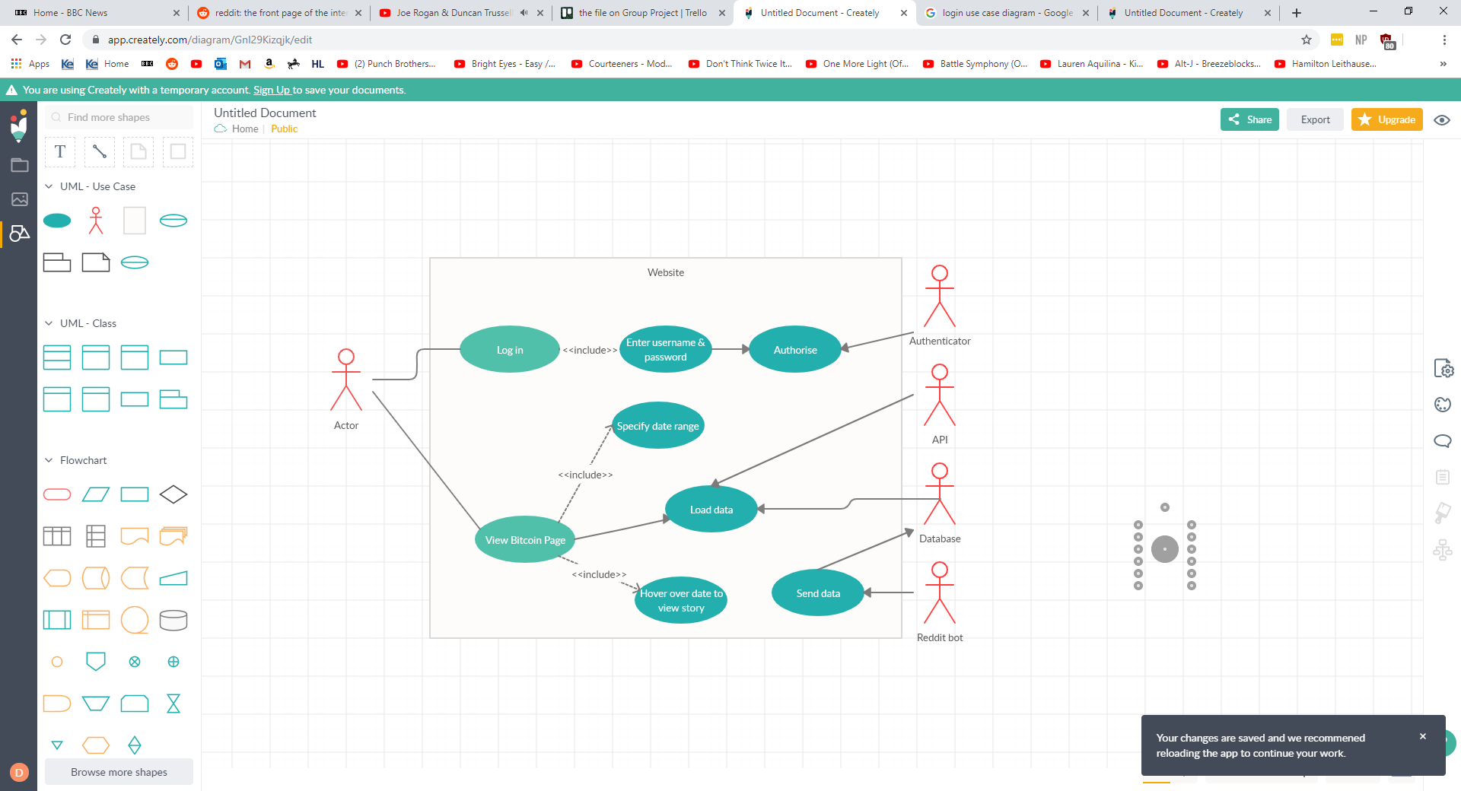

**Scenario:** I want to compare my performance with that of another user. (specify inputs in relation to performance for user stories)

**User story:**

As a user, I want to compare my inputs over the last week with another user in order to determine who made better inputs during this time.

**Requirements:**

Database/Table storage. Login/authentication system. Account details page with option for history of inputs. Account comparison feature. API.

**Use Case Diagram:**

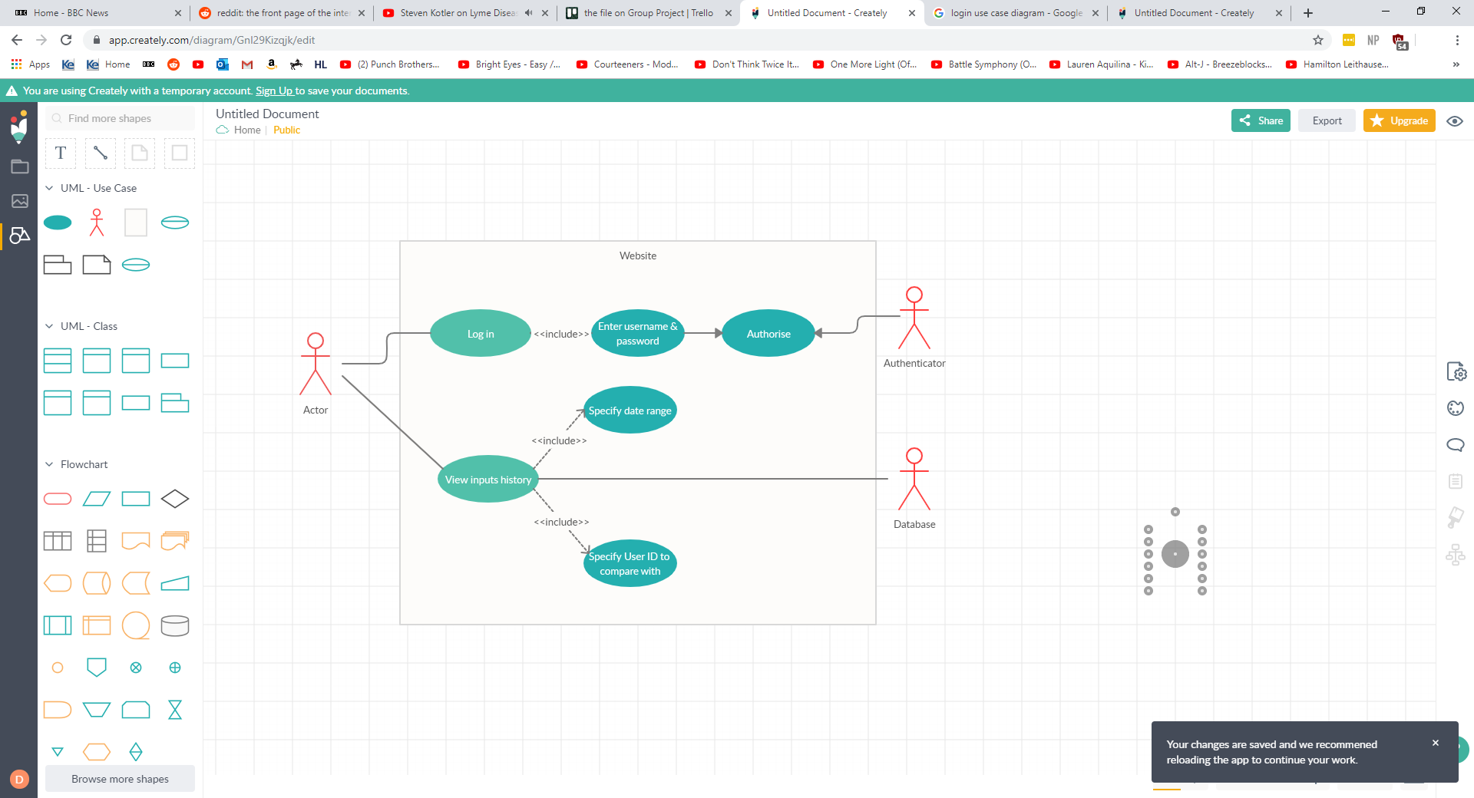

**Sequence Diagram**

